Crop Yield Prediction

A Project Report Submitted in
the partial fulfillment of the requirements for the award of the degree of

BACHELOR OF TECHNOLOGY
In

DEPARTMENT OF COMPUTER SCIENCE AND ENGINEERING
By
K.V.S Jaswant | : 2420030467
D Teja | : 2420030737
K. Bhargav | : 2420030754

Under the Esteemed Guidance of

Dr.N.Sunanda

Associate Professor
Department of Computer Science and Engineering

AY- 2026–2027

Semester: ODD Semester




K L (Deemed to be) University
DEPARTMENT OF COMPUTER SCIENCE AND ENGINEERING

Declaration

The Project Report entitled “Crop Yield Prediction” is a record of bonafide work of K.V.S Jaswant – 2420030467, D. Teja – 2420030737 and K. Bhargav – 2420030754, submitted in partial fulfillment for the award of B.Tech to K L (Deemed to be) University. The results embodied in this report describe the submitted CropPredict project.

K.V.S Jaswant – 2420030467
D. Teja – 2420030737
K. Bhargav – 2420030754

K L (Deemed to be) University
DEPARTMENT OF COMPUTER SCIENCE AND ENGINEERING

CERTIFICATE

This is to certify that the mini project report entitled “Crop Yield Prediction” is a bonafide work done and submitted by K.V.S Jaswant – 2420030467, D. Teja – 2420030737 and K. Bhargav – 2420030754 in partial fulfillment of the requirements for the award of the degree of BACHELOR OF TECHNOLOGY during the academic year 2026–2027.

_____________________
Signature of the Guide
Dr. N. Sunanda
Associate Professor, CSE

_____________________ _____________________
Course Coordinator Head of the Department
Dr. N. Sunanda Dr.P. Venkateswara Rao
Department of CSE Department of CSE

ACKNOWLEDGEMENT
The success in this project would not have been possible but for the timely help and guidance rendered by many people. Our wish to express my sincere thanks to all those who has assisted us in one way or the other for the completion of my project.

Our greatest appreciation to my Course Coordinator and my guide N. Sunanda, Department of Computer Science which cannot be expressed in words for his/her tremendous support, encouragement and guidance for this project.

We express our gratitude to Dr. P. Vekateshwara Rao, Head of the Department for Computer Science and Engineering for providing us with adequate facilities, ways and means by which we are able to complete this project-based Lab.

We thank all the members of teaching and non-teaching staff members, and also who have assisted me directly or indirectly for successful completion of this project. Finally, I sincerely thank my parents, friends and classmates for their kind help and cooperation during my work.

K.V.S Jaswant – 2420030467
D. Teja – 2420030737
K. Bhargav – 2420030754

Abstract
Crop Yield Prediction is a data-driven application designed to analyze agricultural datasets and estimate crop yield from relevant historical and environmental features. Users can upload CSV or Excel files containing information such as crop, season, state or district, area, production, rainfall, temperature, soil properties and other available variables. The system inspects the dataset, identifies usable columns, handles missing values where appropriate and presents summary statistics and visual analysis.

The planned application uses Python, Streamlit, Pandas, NumPy and Scikit-learn for data processing, interactive interface development and machine-learning experiments. Plotly and Matplotlib can be used for charts, while Openpyxl supports Excel input and Joblib can save trained models. Regression models are compared using MAE, RMSE and R² when the uploaded dataset contains a suitable target variable. Results and processed tables can be downloaded for further analysis.

Crop Yield Prediction aims to support agricultural data analysis by converting uploaded datasets into understandable summaries, visualizations and model-based yield estimates. Predictions depend on the quality, coverage and suitability of the uploaded data and should be treated as decision-support estimates rather than guaranteed outcomes.

Index
S. No. | Chapters | Topics | Page.no
 |  | Acknowledgement
 |  | Abstract
1 | Introduction | 1.1 Background of the project  1.2 Problem statement  1.3 Scope of the project  1.4 Objective(s)  1.5 Importance of the application  1.6 Target users/audience | 1-10
2 | System Requirements | 2.1 Hardware requirements  2.2 Software requirements  2.3 Development tools and frameworks | 11-20
3 | Technology Stack | 3.1 Front-end (e.g., React.js, Angular, HTML/CSS)  3.2 Back-end (e.g., Node.js, Django, Spring Boot)  3.3 Database (e.g., MongoDB, MySQL, PostgreSQL)  3.4 Version Control (e.g., Git, GitHub)  3.5 APIs or External services (e.g., Firebase, Stripe) | 21-30
4 | System Architecture | 4.1 High-level architecture diagram  4.2 Description of each layer (frontend, backend, database)  4.3 Deployment architecture (e.g., cloud, local, CI/CD pipelines) | 31-35
5 | Design | 5.1 Wireframes or mockups  5.2 ER Diagram / Database schema | 36-42
6 | Implementation | 6.1 Module-wise implementation  6.2 Front-end logic (UI rendering, state management)  6.3 Backend logic (routes, controllers, business logic)  6.4 Database connectivity  6.5 API integration  6.6 Authentication & Authorization | 43-55
7 | Features | 7.1 List of main features  7.2 How each feature works (user perspective + technical description) | 56-60
8 | Testing | 8.1 Postman testing (frontend/backend)  8.2 Integration testing  8.3 Tools used for testing  8.4 Test cases and results | 61-67
9 | Deployment | 9.1 Steps to deploy  9.2 Environment configuration  9.3 Hosting of frontend and backend | 68-73
10 | Challenges & Limitations | 10.1 Issues faced during development  10.2 Solutions applied  10.3 Current limitations or known bugs | 74-80
11 | Future Enhancements | 11.1 Planned features  11.2 Possible integrations or optimizations | 81-88
12 | Conclusion | 12.1 Summary of the project  12.2 What was achieved  12.3 Skills learned during development | 89-100
13 | References | - Books, tutorials, APIs, documentation sites used
14 | Appendices | - Screenshots of the app  - Sample code snippets  - Installation/setup instructions  - User manual or guide  -certifications

CHAPTER 1
Introduction

  - Motivation

Agricultural production is affected by factors such as rainfall, temperature, soil conditions, crop type, season and farming practices. Historical agricultural datasets often contain useful patterns, but they can be difficult to interpret manually. This project provides a simple workflow for uploading a dataset, exploring its contents, preparing data for analysis and applying machine-learning models when suitable target and feature columns are available.

  - Objective
The main objective is to build an accessible Crop Yield Prediction application that accepts CSV and Excel datasets, performs data validation and preprocessing, displays exploratory data analysis, trains and compares suitable regression models, reports evaluation metrics and generates yield estimates from supported input features. Crop-wise or region-wise rankings are shown only when the dataset contains the information needed to calculate them reliably.
1.3 What is Crop Yield Prediction?
Crop yield prediction is the process of estimating agricultural output using historical production records and relevant variables such as crop type, cultivated area, season, weather and soil conditions. Data analysis and machine-learning techniques can identify relationships in past observations and use them to estimate yield for records with comparable inputs.web siteInternetWorld Wide Webintranetstatic pageplain textinternet applicationselectronic businessessocial network servicesweb engineeringweb designweb content developmentclient-sideserver-sidescriptingwebserver
The reliability of a prediction depends on the amount and quality of the data, the consistency of units, the relevance of the selected features and the way the model is evaluated. A model should be tested on data that was not used for training, and its performance should be reported with appropriate error metrics.markupcodingcontent management systems
This project focuses on a practical data workflow: upload a dataset, inspect columns and missing values, clean and visualize the data, select a valid target column, train candidate regression models and compare their results. The application should clearly identify unsupported inputs and avoid presenting illustrative values as verified predictions.web developersAgile methodologiesgraphic designerinformation systemsfront-end developerfull-stack developer

1.4 Importance of Agricultural Data
Agricultural datasets can contain crop production, cultivated area, location, season and environmental observations. Organizing these records helps users compare trends across crops, years and regions, and identify data quality issues before modelling.web resourcesmultimediadomain nameweb serverwikipedia.orggoogle.comamazon.com
Exploratory data analysis uses tables, summary statistics and charts to understand distributions, missing values, outliers and relationships among variables. These steps help users understand the dataset and decide whether it is appropriate for yield prediction.Internet ProtocolInternetlocal area networkuniform resource locator
A prediction system can assist learning and preliminary analysis, but it cannot account for every real-world condition. Local agronomic knowledge and current field conditions remain important when interpreting its output.personal websitesocial networkingWorld Wide Webintranet

1.5 Machine Learning for Yield Estimation
Supervised regression learns a relationship between input features and a numeric target such as yield per hectare or production. The target column and its units must be identified correctly before training.web resourceWorld Wide Webweb browsersoftwareInternetmonitormobile devicehypertexthyperlinks
Candidate models may include Linear Regression, Decision Tree Regressor, Random Forest Regressor and Gradient Boosting Regressor. The application should use only models supported by the installed libraries and the dataset size, and should compare them using a consistent train-test split.source codetext filehypertextHTMLmarkup languageweb resourcestyle sheetsscripts

CHAPTER 2
Software Requirement

2.1 Problem Statement
Problem Statement: Agricultural datasets are often distributed in different CSV and Excel formats, with varying column names, missing values and units. Users need a straightforward tool to inspect these files, understand their patterns and estimate crop yield when the available data supports supervised learning. The proposed system provides upload, preprocessing, visualization, model evaluation and downloadable results in one interface.
  - Technologies Used

- Python: The main programming language for data cleaning, analysis, machine-learning model training and prediction.markup languageweb browserCascading Style Sheetsscripting languagesJavaScript
Core Python Workflow:
Load CSV or Excel dataset → inspect columns and data types → clean and preprocess records → visualize data → select features and target → train and evaluate regression models → display and download results.

- Pandas and NumPy: Pandas is used to load, filter, clean and summarize tabular data. NumPy supports numerical operations used during preprocessing and analysis.style-sheetHTMLXMLSVGMath-MLXHTML
Scikit-learn: Provides preprocessing utilities, train-test splitting, regression algorithms and evaluation metrics such as mean absolute error (MAE), root mean squared error (RMSE) and coefficient of determination (R²).W3C specificationCSS3

Visualization and Interface Tools:
Streamlit: Creates the interactive application interface, including dataset upload, controls, tables, charts and prediction outputs.
Plotly: Creates interactive charts for crop-wise, season-wise, location-wise and other comparisons when the required columns are present in the dataset.
Matplotlib: An optional visualization library for static charts and additional exploratory analysis.

- Supporting Libraries: Openpyxl enables reading Excel workbooks through Pandas. Joblib can be used to save and load trained models where model persistence is required. Python standard libraries support file handling and application utilities.free and open-sourceCSS frameworkfront-end web developmentCSSJavaScripttypographyformsbuttonsnavigationGit-Hubfree Code CampVue.jsAlexa RankTwitter

  - Software Used
2.3.1 Visual Studio Code: Visual Studio Code is the recommended editor for developing and running the Python application. A project-specific virtual environment can be used to install dependencies from requirements.txt and keep the project setup reproducible.source code editorAdobe Systemsfree and open-source softwareMIT LicenseGit-HubJavaScriptHTMLCSScross-platformmac-OSWindowsLinux distributionsHTMLCSSJavaScript
AdobeThe application can be launched on Windows from the project directory after activating the virtual environment and installing dependencies. The typical command is: python -m streamlit run app.py. The exact entry-point filename should match the file created for the application.web developmentEdge CodeAdobeAdobeweb developmentGit-Hub

CHAPTER 3
Software Design

3.1 DFD
A data-flow diagram (DFD) is a way of representing a flow of a data of a process or a system (usually an information system). The DFD also provides information about the outputs and inputs of each entity and the process itself. A data-flow diagram has no control flow, there are no decision rules and no loops. Specific operations based on the data can be represented by a flowchart.
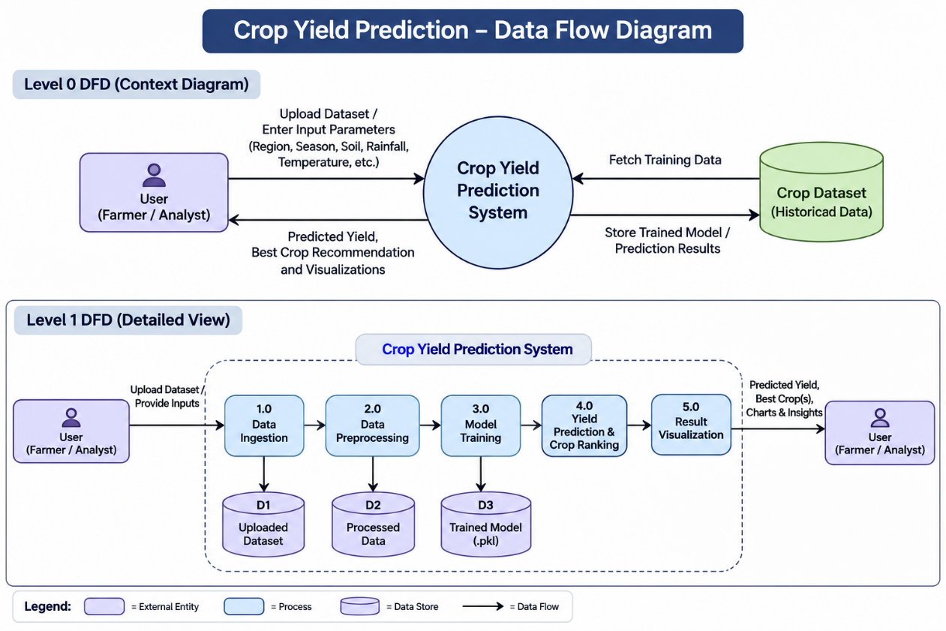
Fig No. 3.1 DFD LEVEL-0

CHAPTER 4
Implementation and User Interface

4.1 Application Workflow
- Dataset Upload: The user uploads a CSV or Excel file. The application checks whether the file can be read and displays a preview of its rows and columns.
- Dataset Overview: The system reports row and column counts, column types, missing values and basic descriptive statistics to help users understand the uploaded data.
- CropPredict helps users evaluate agricultural conditions and view a ranked shortlist of suitable crops. The interface accepts region, growing season, soil type, soil quality, rainfall, temperature, humidity, fertilizer, irrigation and previous yield, then displays rule-based suitability guidance and an illustrative yield estimate.
- Data Preparation and Prediction: The user selects or confirms the target column and relevant features. The application prepares eligible records, trains supported regression models and displays predictions only when the required inputs are available.
- Analytics Dashboard: Charts and comparison tables summarize the available data. Model performance is reported using MAE, RMSE and R² when evaluation is possible. Crop rankings are produced only if the dataset has comparable crop identifiers and a suitable yield or production measure.

4.2 Detailed Description of Modules

The Crop Yield Prediction system consists of five major modules. Each module performs a specific task, from uploading agricultural datasets to predicting crop yield and displaying the results to the user.

4.2.1 Data Ingestion Module
The Data Ingestion Module is responsible for collecting agricultural data from the user. The system allows users to upload datasets in CSV and Excel formats. The uploaded dataset may contain information such as crop type, state, district, season, rainfall, temperature, soil characteristics, cultivated area, and historical crop production.
The module checks whether the uploaded file is readable and contains valid data. It identifies the available columns and displays a preview of the dataset. This helps users understand the structure and contents of the data before proceeding to the next stage.
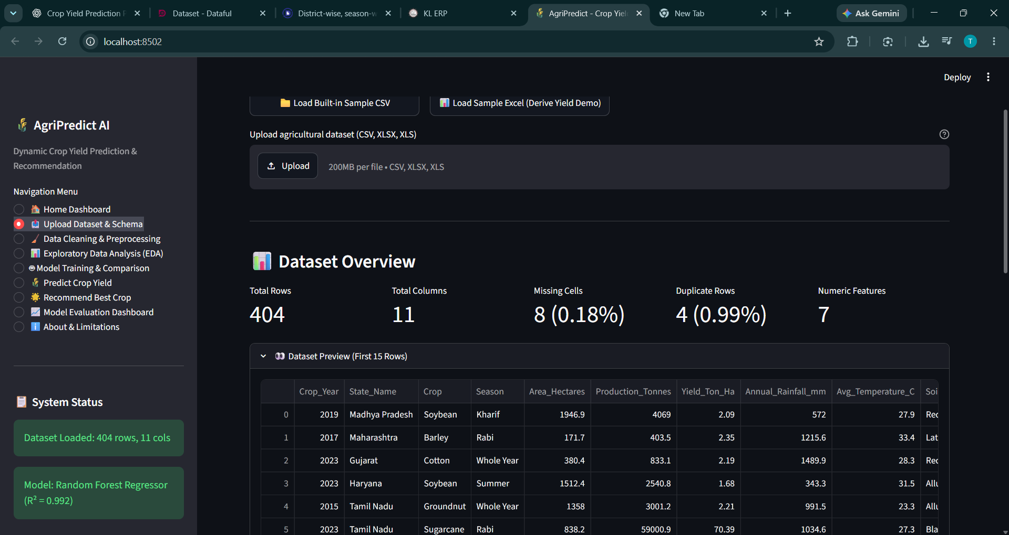

4.2.2 Data Preprocessing Module
The Data Preprocessing Module prepares the collected data for machine-learning operations. Agricultural datasets may contain missing values, duplicate records, inconsistent formats, and non-numeric values. This module handles these issues to improve data quality and model reliability.
The module performs appropriate data cleaning, handles missing values, removes duplicate records when necessary, and converts categorical variables into a suitable numerical representation. It also identifies the relevant input features and the target variable, such as crop yield, based on the dataset's available columns.
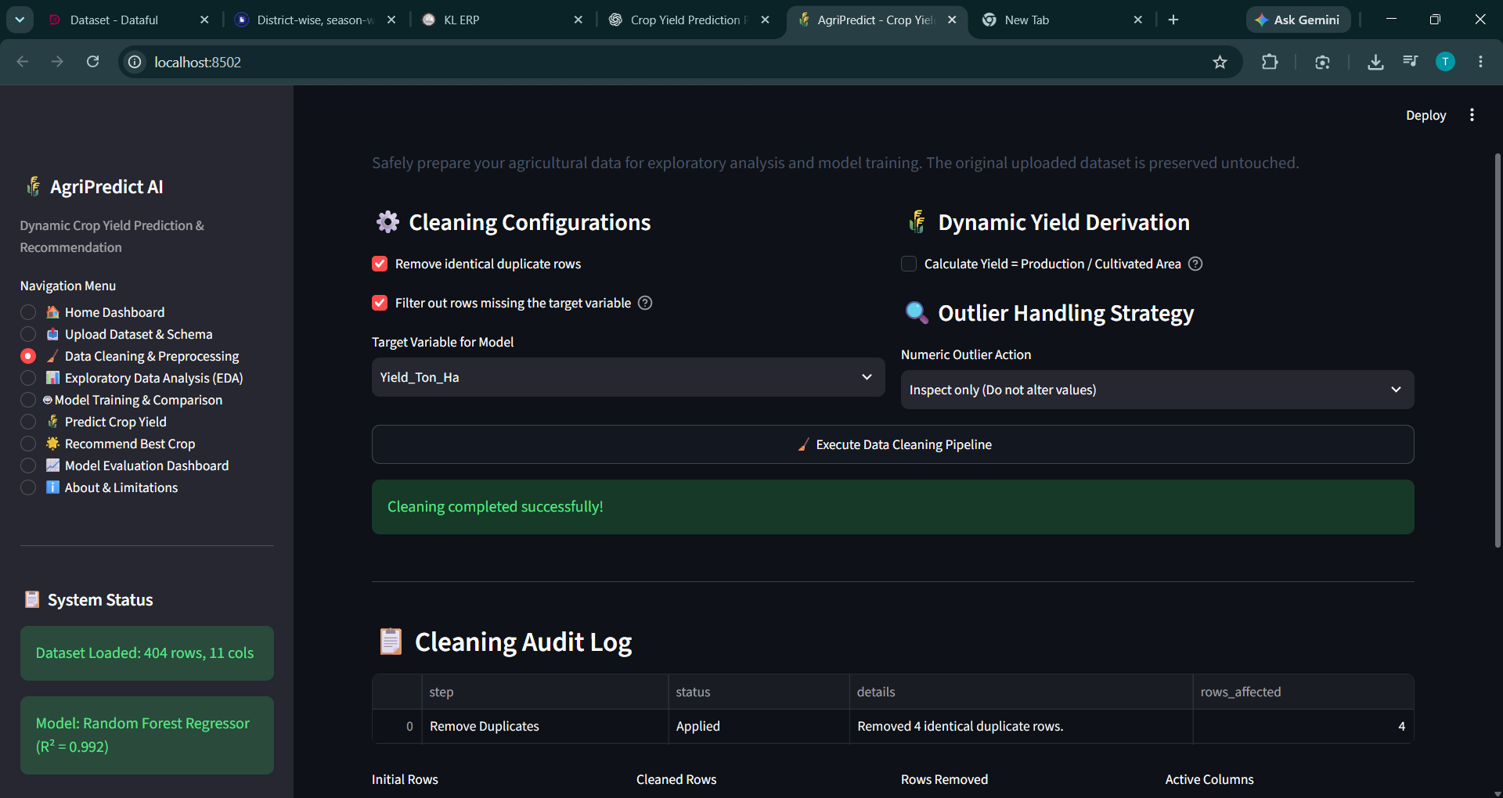

4.2.3 Model Training Module
The Model Training Module applies machine-learning algorithms to historical agricultural data to learn the relationship between input features and crop yield. The preprocessed dataset is divided into training and testing subsets to evaluate how well the models perform on unseen data.
The system can use regression algorithms such as Linear Regression, Decision Tree Regressor, Random Forest Regressor, and Gradient Boosting Regressor. Their performance is compared using evaluation metrics such as Mean Absolute Error (MAE), Root Mean Squared Error (RMSE), and the coefficient of determination (\(R^2\)).
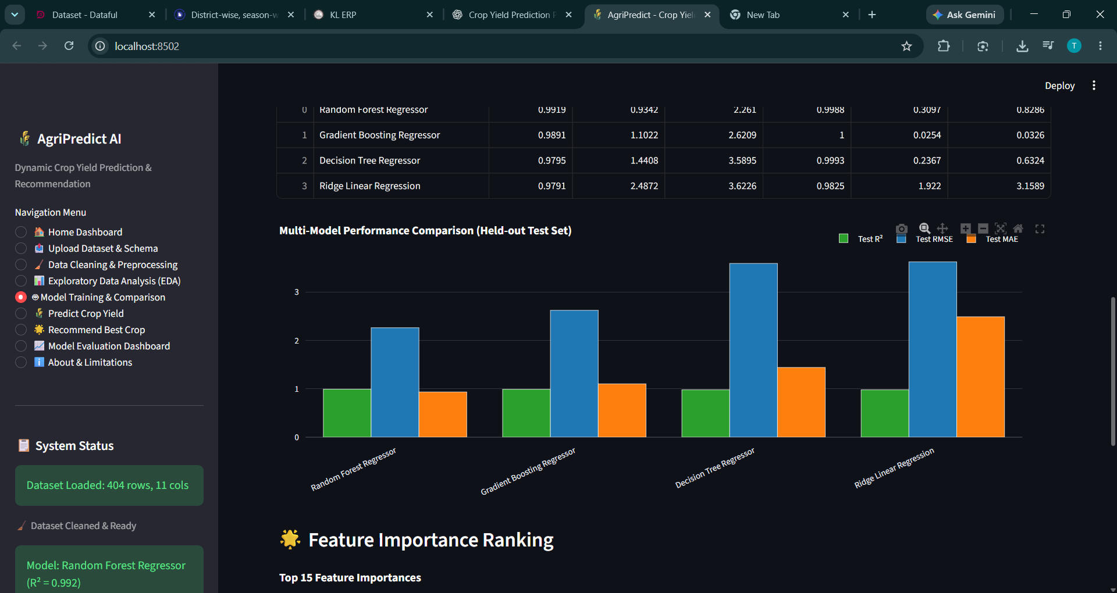
4.2.4 Yield Prediction and Crop Ranking Module
The Yield Prediction and Crop Ranking Module uses a trained machine-learning model to estimate crop yield based on the input parameters supplied by the user. Depending on the dataset, these parameters may include crop type, region, season, rainfall, temperature, soil characteristics, and other relevant features.
The model processes the input values and generates an estimated yield in the unit supported by the training dataset. If the dataset contains comparable yield information for multiple crops under relevant conditions, the system can also rank the crops according to their predicted yields.

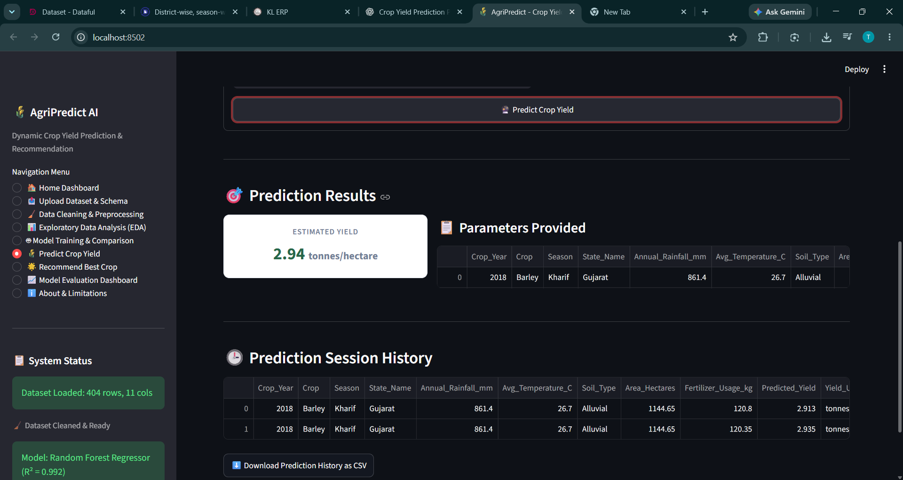
4.2.5 Result Visualization Module
The Result Visualization Module presents the output of the analysis in an understandable and interactive format. It helps users interpret the dataset, evaluate model performance, and understand the predicted crop yield. The system can display charts, summary statistics, model evaluation metrics, and prediction results using visualization libraries such as Plotly and Matplotlib. It can also provide downloadable prediction results for further analysis.
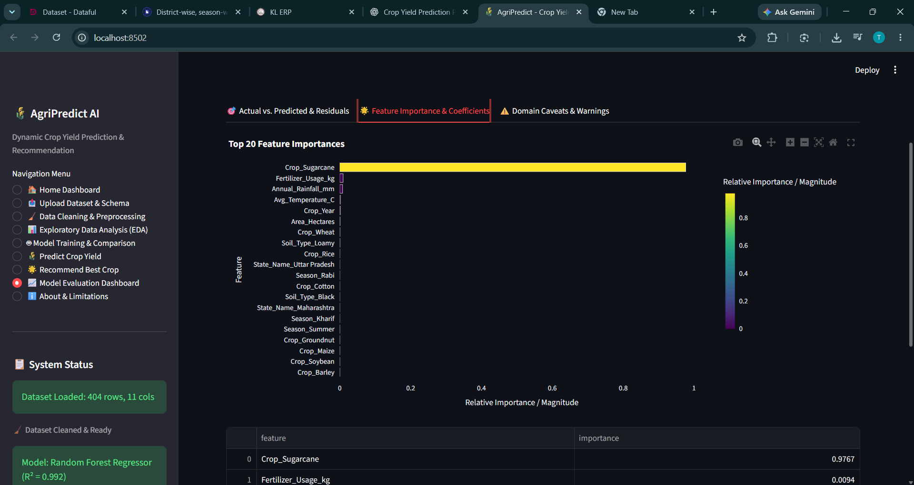

CHAPTER 5

Conclusion and Future Aspects

The Crop Yield Prediction project provides a structured workflow for uploading agricultural data, inspecting and preparing records, visualizing patterns and evaluating regression models. Its results can help users explore historical data and understand possible yield estimates. The system must report its limitations clearly, and the accuracy of its predictions must be established through testing on a suitable dataset rather than assumed.
CropPredict has been implemented as a responsive browser-based prototype for crop recommendation and illustrative yield estimation. It collects agricultural inputs, applies transparent crop-suitability rules, ranks candidate crops and presents results through a dashboard. The project demonstrates how web technologies and data-oriented reasoning can be combined for an agricultural decision-support interface.
Future enhancements may include integration with trusted weather and agricultural data sources, broader validation across regions and seasons, improved handling of inconsistent units, model persistence, explainability tools and deployment to a hosted service. These features should be added only after data availability, licensing and model performance have been assessed.
- Future enhancement: Add a dataset-guidance panel that explains required columns, target selection and supported file formats before the user starts analysis.
- Future enhancement: Add model comparison charts and downloadable evaluation reports, including clear explanations of MAE, RMSE and R² and warnings when the dataset is too small or unsuitable.
- We can add sms tool so that the information about the Restaurant can be provided using SMS.

CHAPTER 6
Bibliography

- https://www.w3schools.com/html/default.asphttps://www.python.org/
- https://www.w3schools.com/css/default.asphttps://pandas.pydata.org/
- https://www.w3schools.com/bootstrap4/default.asphttps://scikit-learn.org/stable/
- https://mdbootstrap.com/docs/jquery/javascript/carousel/https://docs.streamlit.io/

CHAPTER 7

Appendices

Main Application – app.py
The following source code implements the Crop Yield Prediction application. It provides facilities for uploading agricultural datasets, preprocessing data, performing exploratory data analysis, training machine-learning models, evaluating model performance, and predicting crop yield. The application uses Streamlit to provide a user-friendly interface.
Programming Language : Python
Framework : Streamlit
Libraries: Pandas, NumPy, Scikit-learn, Plotly and Matplotlib
Source Code:
"""
Crop Yield Prediction and Recommendation System
Modern Streamlit web application for end-to-end dynamic agricultural data analysis,
automated machine learning, inference, and crop ranking.
"""

from __future__ import annotations
import io
import os
from typing import Any, Dict, List, Optional
import numpy as np
import pandas as pd
import streamlit as st

# Import core modules
from src.dataset_loader import (
load_dataset,
compute_dataset_stats,
DatasetLoadError,
export_dataframe_to_csv,
export_dataframe_to_excel,
)
from src.schema_detector import (
detect_schema_mappings,
can_derive_yield,
ROLE_DEFINITIONS,
)
from src.data_cleaner import clean_dataset
from src.eda import (
plot_missing_values_chart,
plot_crop_distribution,
plot_crop_yield_comparison,
plot_historical_yield_trends,
plot_region_yield_comparison,
plot_correlation_heatmap,
plot_weather_analysis,
plot_feature_distribution,
)
from src.model_trainer import (
train_and_compare_models,
save_trained_bundle,
TrainingError,
)
from src.model_evaluator import (
plot_actual_vs_predicted,
plot_residuals,
plot_feature_importance_chart,
create_models_comparison_table,
plot_model_comparison_bar,
generate_limitations_and_warnings,
)
from src.predictor import predict_single_instance, PredictionValidationError
from src.crop_recommender import (
can_support_crop_recommendation,
compare_and_rank_crops,
plot_crop_ranking_chart,
CropRecommendationError,
)

# --- PAGE SETUP & CUSTOM CSS ---
st.set_page_config(
page_title="AgriPredict - Crop Yield AI",
page_icon="🌾",
layout="wide",
initial_sidebar_state="expanded",
)

st.markdown("""
<style>
/* Main container styling */
.main-title {
font-size: 2.2rem;
font-weight: 800;
color: #1e3a1e;
margin-bottom: 0.2rem;
}
.sub-title {
font-size: 1.05rem;
color: #4a5568;
margin-bottom: 1.5rem;
}
.metric-card {
background: #ffffff;
border: 1px solid #e2e8f0;
border-radius: 10px;
padding: 1.1rem;
box-shadow: 0 1px 3px rgba(0,0,0,0.05);
text-align: center;
}
.metric-label {
font-size: 0.85rem;
font-weight: 600;
color: #718096;
text-transform: uppercase;
letter-spacing: 0.05em;
}
.metric-value {
font-size: 1.8rem;
font-weight: 700;
color: #276749;
margin-top: 0.2rem;
}
.badge-success {
display: inline-block;
background: #c6f6d5;
color: #22543d;
padding: 0.25rem 0.6rem;
border-radius: 6px;
font-size: 0.8rem;
font-weight: 600;
}
.badge-warning {
display: inline-block;
background: #feebc8;
color: #744210;
padding: 0.25rem 0.6rem;
border-radius: 6px;
font-size: 0.8rem;
font-weight: 600;
}
.badge-info {
display: inline-block;
background: #e2e8f0;
color: #2d3748;
padding: 0.25rem 0.6rem;
border-radius: 6px;
font-size: 0.8rem;
font-weight: 600;
}
.card-container {
background-color: #f7fafc;
border: 1px solid #edf2f7;
border-radius: 8px;
padding: 1.2rem;
margin-bottom: 1.2rem;
}
</style>
""", unsafe_allow_html=True)

# --- SESSION STATE INITIALIZATION ---
if "raw_df" not in st.session_state:
st.session_state.raw_df = None
if "cleaned_df" not in st.session_state:
st.session_state.cleaned_df = None
if "dataset_meta" not in st.session_state:
st.session_state.dataset_meta = None
if "schema_mapping" not in st.session_state:
st.session_state.schema_mapping = {}
if "cleaning_summary" not in st.session_state:
st.session_state.cleaning_summary = None
if "trained_bundle" not in st.session_state:
st.session_state.trained_bundle = None
if "predictions_history" not in st.session_state:
st.session_state.predictions_history = []
if "last_recommendation" not in st.session_state:
st.session_state.last_recommendation = None

# --- SIDEBAR NAVIGATION ---
st.sidebar.markdown("## 🌾 AgriPredict AI")
st.sidebar.caption("Dynamic Crop Yield Prediction & Recommendation")

menu_choice = st.sidebar.radio(
"Navigation Menu",
[
"🏠 Home Dashboard",
"📤 Upload Dataset & Schema",
"🧹 Data Cleaning & Preprocessing",
"📊 Exploratory Data Analysis (EDA)",
"🤖 Model Training & Comparison",
"🌾 Predict Crop Yield",
"🌟 Recommend Best Crop",
"📈 Model Evaluation Dashboard",
"ℹ️ About & Limitations",
],
index=0,
)

# Sidebar System Status Card
st.sidebar.markdown("---")
st.sidebar.markdown("### 📋 System Status")

if st.session_state.raw_df is not None:
n_rows = len(st.session_state.raw_df)
n_cols = len(st.session_state.raw_df.columns)
st.sidebar.success(f"Dataset Loaded: {n_rows:,} rows, {n_cols} cols")
if st.session_state.cleaned_df is not None:
st.sidebar.caption("🧹 Dataset Cleaned & Ready")
else:
st.sidebar.info("Dataset: No file loaded")

if st.session_state.trained_bundle is not None:
b_name = st.session_state.trained_bundle["best_model_name"]
b_r2 = st.session_state.trained_bundle["best_metrics"]["R2"]
st.sidebar.success(f"Model: {b_name} (R² = {b_r2:.3f})")
else:
st.sidebar.caption("Model: Untrained")

# -------------------------------------------------------------
# PAGE 1: 🏠 HOME DASHBOARD
# -------------------------------------------------------------
if menu_choice == "🏠 Home Dashboard":
st.markdown('<div class="main-title">Crop Yield Prediction & Recommendation System</div>', unsafe_allow_html=True)
st.markdown(
'<div class="sub-title">A dynamic, machine-learning-powered agronomic decision support platform. '
'Upload your agricultural data, automatically train predictive models, explore historical patterns, '
'and discover the highest-yielding crops for your region.</div>',
unsafe_allow_html=True,
)

# Top KPI Metrics Cards
col1, col2, col3, col4 = st.columns(4)
with col1:
st.markdown(
f'<div class="metric-card"><div class="metric-label">Dataset Records</div>'
f'<div class="metric-value">{len(st.session_state.raw_df) if st.session_state.raw_df is not None else 0:,}</div></div>',
unsafe_allow_html=True,
)
with col2:
st.markdown(
f'<div class="metric-card"><div class="metric-label">Active Features</div>'
f'<div class="metric-value">{len(st.session_state.trained_bundle["feature_cols"]) if st.session_state.trained_bundle is not None else 0}</div></div>',
unsafe_allow_html=True,
)
with col3:
best_r2_val = (
f"{st.session_state.trained_bundle['best_metrics']['R2']:.3f}"
if st.session_state.trained_bundle is not None
else "N/A"
)
st.markdown(
f'<div class="metric-card"><div class="metric-label">Model R² Score</div>'
f'<div class="metric-value">{best_r2_val}</div></div>',
unsafe_allow_html=True,
)
with col4:
st.markdown(
f'<div class="metric-card"><div class="metric-label">Predictions Logged</div>'
f'<div class="metric-value">{len(st.session_state.predictions_history)}</div></div>',
unsafe_allow_html=True,
)

st.markdown("### 🚀 Guided Workflow")
st.markdown("""
1. **Upload Dataset (`📤`)**: Upload your agricultural CSV or Excel file. The system dynamically maps column roles (Crop, Yield, Rainfall, Soil, etc.).
2. **Data Cleaning (`🧹`)**: Remove duplicates, handle missing values, cap outliers, and optionally derive Yield = Production / Area.
3. **Exploratory Data Analysis (`📊`)**: Interactive Plotly visualizations for yield distributions, temporal trends, and correlation heatmaps.
4. **Automated ML Training (`🤖`)**: Automatically trains and benchmarks Ridge Regression, Decision Trees, Random Forests, and Gradient Boosting on held-out test data.
5. **Predict Yield (`🌾`)**: Enter local field and weather conditions to forecast expected crop yield with extrapolation warnings.
6. **Recommend Best Crop (`🌟`)**: Compare all supported candidate crops under identical weather and soil conditions to find the optimal yield.
7. **Evaluation Dashboard (`📈`)**: Diagnostic plots, actual vs. predicted comparisons, residual analysis, and agronomic limitations.
""")

st.markdown("---")
st.info("💡 **Quick Start**: If you don't have an agricultural dataset ready, navigate to the **'Upload Dataset & Schema'** page and click **'Load Sample Dataset'** for an instant demo!")

# -------------------------------------------------------------
# PAGE 2: 📤 UPLOAD DATASET & SCHEMA MAPPING
# -------------------------------------------------------------
elif menu_choice == "📤 Upload Dataset & Schema":
st.markdown('<div class="main-title">Dataset Upload & Schema Mapping</div>', unsafe_allow_html=True)
st.markdown(
'<div class="sub-title">Upload your agricultural dataset in CSV or Excel format. '
'The application dynamically inspects the file, detects key agricultural features, and lets you verify column roles.</div>',
unsafe_allow_html=True,
)

# Demo Dataset Loader Button
col_demo1, col_demo2 = st.columns([1, 3])
with col_demo1:
if st.button("📁 Load Built-in Sample CSV", use_container_width=True):
sample_path = "data/agricultural_yield_dataset.csv"
if os.path.exists(sample_path):
df_loaded, meta = load_dataset(sample_path)
st.session_state.raw_df = df_loaded
st.session_state.dataset_meta = meta
st.session_state.cleaned_df = None
st.session_state.schema_mapping = detect_schema_mappings(df_loaded)
st.success("Loaded built-in agricultural sample dataset!")
st.rerun()
else:
st.error("Sample dataset file not found on disk.")

with col_demo2:
if st.button("📊 Load Sample Excel (Derive Yield Demo)", use_container_width=False):
excel_path = "data/crop_production_derive_yield.xlsx"
if os.path.exists(excel_path):
df_loaded, meta = load_dataset(excel_path)
st.session_state.raw_df = df_loaded
st.session_state.dataset_meta = meta
st.session_state.cleaned_df = None
st.session_state.schema_mapping = detect_schema_mappings(df_loaded)
st.success("Loaded Excel dataset without explicit Yield (ready for Yield derivation)!")
st.rerun()

uploaded_file = st.file_uploader(
"Upload agricultural dataset (CSV, XLSX, XLS)",
type=["csv", "xlsx", "xls"],
help="Upload any agricultural dataset. No hardcoded schemas required.",
)

if uploaded_file is not None:
try:
df_loaded, meta = load_dataset(uploaded_file, uploaded_file.name)
# Only update if new file loaded
if (
st.session_state.dataset_meta is None
or st.session_state.dataset_meta.get("file_name") != meta["file_name"]
):
st.session_state.raw_df = df_loaded
st.session_state.dataset_meta = meta
st.session_state.cleaned_df = None
st.session_state.schema_mapping = detect_schema_mappings(df_loaded)
st.success(f"Successfully loaded '{meta['file_name']}'!")
st.rerun()
except DatasetLoadError as dle:
st.error(f"Dataset Loading Error: {dle}")
st.info("Ensure your file has valid column headers and delimiter-separated rows.")
except Exception as ex:
st.error(f"Unexpected error while reading file: {ex}")

# Display dataset details if loaded
if st.session_state.raw_df is not None:
df = st.session_state.raw_df
stats = compute_dataset_stats(df)

st.markdown("---")
st.markdown("### 📊 Dataset Overview")

# Metric badges
m1, m2, m3, m4, m5 = st.columns(5)
m1.metric("Total Rows", f"{stats['total_rows']:,}")
m2.metric("Total Columns", stats['total_cols'])
m3.metric("Missing Cells", f"{stats['total_missing_cells']:,} ({stats['overall_missing_pct']}%)")
m4.metric("Duplicate Rows", f"{stats['duplicate_rows']} ({stats['duplicate_pct']}%)")
m5.metric("Numeric Features", len(stats['numeric_cols']))

# Data preview
with st.expander("👀 Dataset Preview (First 15 Rows)", expanded=True):
st.dataframe(df.head(15), use_container_width=True)

# Detailed column stats table
with st.expander("📋 Column Details & Missing Values Breakdown", expanded=False):
col_details_df = pd.DataFrame(stats["column_details"])
st.dataframe(col_details_df, use_container_width=True)

# Dynamic Schema Role Mapping Card
st.markdown("---")
st.markdown("### 🔍 Semantic Agricultural Role Detection")
st.markdown(
"The system automatically analyzed your dataset columns to suggest agricultural roles. "
"Please confirm or adjust the mappings below if needed."
)

detected = st.session_state.schema_mapping
all_cols_options = ["(None / Unmapped)"] + list(df.columns)

col_left, col_right = st.columns(2)
confirmed_mapping: Dict[str, Optional[str]] = {}

role_keys = list(ROLE_DEFINITIONS.keys())
half = len(role_keys) // 2

with col_left:
for rk in role_keys[:half]:
meta = detected.get(rk, {})
auto_col = meta.get("column")
idx = all_cols_options.index(auto_col) if auto_col in all_cols_options else 0
chosen = st.selectbox(
f"{ROLE_DEFINITIONS[rk]['label']}",
options=all_cols_options,
index=idx,
key=f"schema_sel_{rk}",
help=meta.get("reason", ""),
)
confirmed_mapping[rk] = chosen if chosen != "(None / Unmapped)" else None

with col_right:
for rk in role_keys[half:]:
meta = detected.get(rk, {})
auto_col = meta.get("column")
idx = all_cols_options.index(auto_col) if auto_col in all_cols_options else 0
chosen = st.selectbox(
f"{ROLE_DEFINITIONS[rk]['label']}",
options=all_cols_options,
index=idx,
key=f"schema_sel_{rk}",
help=meta.get("reason", ""),
)
confirmed_mapping[rk] = chosen if chosen != "(None / Unmapped)" else None

# Check Yield availability
yield_col = confirmed_mapping.get("yield")
if not yield_col:
st.warning("⚠️ No explicit 'Yield' column mapped.")
can_derive, derive_msg = can_derive_yield(confirmed_mapping, df)
if can_derive:
st.success(f"💡 {derive_msg}. You can compute this in the **Data Cleaning** page!")
else:
st.info(f"ℹ️ {derive_msg}")

if st.button("✅ Confirm Schema Mappings", use_container_width=True):
# Update detected mapping with confirmed selections
for rk, col_val in confirmed_mapping.items():
if rk in st.session_state.schema_mapping:
st.session_state.schema_mapping[rk]["column"] = col_val
else:
st.session_state.schema_mapping[rk] = {"column": col_val, "confidence": 1.0}
st.success("Column schema mappings confirmed! Proceed to Data Cleaning.")

# -------------------------------------------------------------
# PAGE 3: 🧹 DATA CLEANING & PREPROCESSING
# -------------------------------------------------------------
elif menu_choice == "🧹 Data Cleaning & Preprocessing":
st.markdown('<div class="main-title">Data Cleaning & Preprocessing</div>', unsafe_allow_html=True)
st.markdown(
'<div class="sub-title">Safely prepare your agricultural data for exploratory analysis and model training. '
'The original uploaded dataset is preserved untouched.</div>',
unsafe_allow_html=True,
)

if st.session_state.raw_df is None:
st.warning("Please upload a dataset first in the **Upload Dataset & Schema** page.")
else:
df_raw = st.session_state.raw_df
mapping = {k: v.get("column") for k, v in st.session_state.schema_mapping.items()}

col_opt1, col_opt2 = st.columns(2)

with col_opt1:
st.markdown("#### ⚙️ Cleaning Configurations")
remove_dups = st.checkbox("Remove identical duplicate rows", value=True)
drop_na_target = st.checkbox(
"Filter out rows missing the target variable",
value=True,
help="Supervised ML cannot train on missing labels. Silently fabricating real-world yield creates label leakage.",
)

# Target selection
all_cols = list(df_raw.columns)
default_target = mapping.get("yield")
target_idx = all_cols.index(default_target) if default_target in all_cols else 0
selected_target = st.selectbox(
"Target Variable for Model",
options=all_cols,
index=target_idx,
)

with col_opt2:
st.markdown("#### 🌾 Dynamic Yield Derivation")
# Check if user wants to derive yield
can_derive, derive_msg = can_derive_yield(mapping, df_raw)
derive_yield_checked = st.checkbox(
"Calculate Yield = Production / Cultivated Area",
value=(mapping.get("yield") is None and can_derive),
disabled=not can_derive,
help=derive_msg,
)
area_col = mapping.get("area")
prod_col = mapping.get("production")

if derive_yield_checked:
st.caption(f"Will compute: `{prod_col}` / `{area_col}` (excluding non-positive area).")

st.markdown("#### 🔍 Outlier Handling Strategy")
outlier_strategy = st.selectbox(
"Numeric Outlier Action",
options=["inspect", "cap_iqr", "drop_extreme"],
format_func=lambda x: {
"inspect": "Inspect only (Do not alter values)",
"cap_iqr": "Cap at IQR bounds (1.5x IQR)",
"drop_extreme": "Remove extreme outliers (3.0x IQR)",
}[x],
)

# Trigger Cleaning
if st.button("🧹 Execute Data Cleaning Pipeline", use_container_width=True):
with st.spinner("Processing data cleaning operations..."):
cleaned_df, summary = clean_dataset(
df_raw=df_raw,
target_col=selected_target,
remove_duplicates=remove_dups,
drop_missing_target=drop_na_target,
derive_yield=derive_yield_checked,
area_col=area_col,
prod_col=prod_col,
yield_col_name="Yield",
outlier_action=outlier_strategy,
)
st.session_state.cleaned_df = cleaned_df
st.session_state.cleaning_summary = summary
if derive_yield_checked and "Yield" in cleaned_df.columns:
st.session_state.schema_mapping["yield"] = {"column": "Yield", "confidence": 1.0}
st.success("Cleaning completed successfully!")

# Display results if cleaned
active_df = st.session_state.cleaned_df if st.session_state.cleaned_df is not None else df_raw
summary = st.session_state.cleaning_summary

if summary is not None:
st.markdown("---")
st.markdown("### 📋 Cleaning Audit Log")

log_records = summary["audit_log"]
if log_records:
st.dataframe(pd.DataFrame(log_records), use_container_width=True)

kpi1, kpi2, kpi3, kpi4 = st.columns(4)
kpi1.metric("Initial Rows", f"{summary['initial_rows']:,}")
kpi2.metric("Cleaned Rows", f"{summary['final_rows']:,}")
kpi3.metric("Rows Removed", f"{summary['rows_removed']:,}")
kpi4.metric("Active Columns", summary['final_cols'])

# Outlier diagnostics
outlier_data = summary.get("outlier_reports", {})
if outlier_data:
with st.expander("📊 Outlier Detection Report (IQR Method)", expanded=False):
out_rows = []
for col_n, vals in outlier_data.items():
out_rows.append({
"Feature": col_n,
"Outliers Detected": vals["outlier_count"],
"Lower Bound (Q1 - 1.5 IQR)": vals["lower_bound"],
"Upper Bound (Q3 + 1.5 IQR)": vals["upper_bound"],
})
st.dataframe(pd.DataFrame(out_rows), use_container_width=True)

st.markdown("---")
st.markdown("### 📥 Export Cleaned Dataset")
dl_col1, dl_col2 = st.columns(2)
with dl_col1:
csv_bytes = export_dataframe_to_csv(active_df)
st.download_button(
"⬇️ Download Cleaned Data as CSV",
data=csv_bytes,
file_name="cleaned_agricultural_data.csv",
mime="text/csv",
use_container_width=True,
)
with dl_col2:
excel_bytes = export_dataframe_to_excel(active_df)
st.download_button(
"⬇️ Download Cleaned Data as Excel",
data=excel_bytes,
file_name="cleaned_agricultural_data.xlsx",
mime="application/vnd.openxmlformats-officedocument.spreadsheetml.sheet",
use_container_width=True,
)

# -------------------------------------------------------------
# PAGE 4: 📊 EXPLORATORY DATA ANALYSIS (EDA)
# -------------------------------------------------------------
elif menu_choice == "📊 Exploratory Data Analysis (EDA)":
st.markdown('<div class="main-title">Exploratory Data Analysis</div>', unsafe_allow_html=True)
st.markdown(
'<div class="sub-title">Visualize agricultural patterns, crop distributions, weather correlations, '
'and temporal yield trends. All visualizations dynamically reflect your uploaded dataset.</div>',
unsafe_allow_html=True,
)

df_to_use = st.session_state.cleaned_df if st.session_state.cleaned_df is not None else st.session_state.raw_df

if df_to_use is None:
st.warning("Please upload a dataset first in the **Upload Dataset & Schema** page.")
else:
mapping = {k: v.get("column") for k, v in st.session_state.schema_mapping.items()}
crop_col = mapping.get("crop")
yield_col = mapping.get("yield")
year_col = mapping.get("year")
region_col = mapping.get("region")
rainfall_col = mapping.get("rainfall")
temp_col = mapping.get("temperature")

eda_tab1, eda_tab2, eda_tab3, eda_tab4 = st.tabs([
"🌾 Crop & Yield Distributions",
"📈 Historical Trends & Regional Analysis",
"🌦️ Weather & Soil Correlations",
"🔍 Feature Distribution Explorer",
])

with eda_tab1:
st.markdown("#### Crop Distribution & Yield Variances")
c1, c2 = st.columns(2)

with c1:
if crop_col and crop_col in df_to_use.columns:
fig_crop = plot_crop_distribution(df_to_use, crop_col)
if fig_crop:
st.plotly_chart(fig_crop, use_container_width=True)
else:
st.info("Crop column not mapped. Map 'Crop' in the Schema page to see crop distribution.")

with c2:
if crop_col and yield_col and crop_col in df_to_use.columns and yield_col in df_to_use.columns:
fig_box = plot_crop_yield_comparison(df_to_use, crop_col, yield_col)
if fig_box:
st.plotly_chart(fig_box, use_container_width=True)
else:
st.info("Map both 'Crop' and 'Yield' columns to view yield comparisons across crops.")

with eda_tab2:
st.markdown("#### Historical Trends & Geographic Performance")
h1, h2 = st.columns(2)

with h1:
if year_col and yield_col and year_col in df_to_use.columns and yield_col in df_to_use.columns:
fig_trend = plot_historical_yield_trends(df_to_use, year_col, yield_col, crop_col)
if fig_trend:
st.plotly_chart(fig_trend, use_container_width=True)
else:
st.info("Insufficient distinct historical years to construct a trendline.")
else:
st.info("Historical trends require both 'Year' and 'Yield' columns to be mapped.")

with h2:
if region_col and yield_col and region_col in df_to_use.columns and yield_col in df_to_use.columns:
fig_reg = plot_region_yield_comparison(df_to_use, region_col, yield_col)
if fig_reg:
st.plotly_chart(fig_reg, use_container_width=True)
else:
st.info("Regional comparison requires both 'Region/State' and 'Yield' columns.")

with eda_tab3:
st.markdown("#### Environmental Features & Correlation Heatmap")
w1, w2 = st.columns(2)

with w1:
fig_corr = plot_correlation_heatmap(df_to_use)
if fig_corr:
st.plotly_chart(fig_corr, use_container_width=True)
else:
st.info("At least 2 numeric features required for correlation matrix.")

with w2:
if yield_col and yield_col in df_to_use.columns:
weather_figs = plot_weather_analysis(df_to_use, yield_col, rainfall_col, temp_col)
if "rainfall" in weather_figs:
st.plotly_chart(weather_figs["rainfall"], use_container_width=True)
if "temperature" in weather_figs:
st.plotly_chart(weather_figs["temperature"], use_container_width=True)
if not weather_figs:
st.info("Rainfall or Temperature features not mapped or have insufficient data for trendlines.")
else:
st.info("Yield column required for weather relationship plots.")

with eda_tab4:
st.markdown("#### Custom Feature Distribution Viewer")
selected_f = st.selectbox("Select any column to inspect its distribution:", options=df_to_use.columns)
if selected_f:
fig_f = plot_feature_distribution(df_to_use, selected_f)
if fig_f:
st.plotly_chart(fig_f, use_container_width=True)

# Missing value chart
fig_miss = plot_missing_values_chart(df_to_use)
if fig_miss:
st.plotly_chart(fig_miss, use_container_width=True)

# -------------------------------------------------------------
# PAGE 5: 🤖 MODEL TRAINING & COMPARISON
# -------------------------------------------------------------
elif menu_choice == "🤖 Model Training & Comparison":
st.markdown('<div class="main-title">Automated Machine Learning Model Training</div>', unsafe_allow_html=True)
st.markdown(
'<div class="sub-title">Train and benchmark multiple machine learning algorithms. '
'Evaluates on held-out test data, prevents data leakage via isolated ColumnTransformers, '
'and selects the best suited model.</div>',
unsafe_allow_html=True,
)

df_for_ml = st.session_state.cleaned_df if st.session_state.cleaned_df is not None else st.session_state.raw_df

if df_for_ml is None:
st.warning("Please upload a dataset first in the **Upload Dataset & Schema** page.")
else:
mapping = {k: v.get("column") for k, v in st.session_state.schema_mapping.items()}
all_cols = list(df_for_ml.columns)

col_cfg1, col_cfg2 = st.columns(2)

with col_cfg1:
st.markdown("#### 🎯 Target Variable Selection")
default_target = mapping.get("yield")
target_idx = all_cols.index(default_target) if default_target in all_cols else 0
target_column = st.selectbox("Select Target Variable (Continuous Crop Yield)", all_cols, index=target_idx)

yield_unit = st.text_input("Yield Measurement Unit", value="tonnes/hectare")

# Features multi-select
available_features = [c for c in all_cols if c != target_column]
# Default to mapped features if present
default_feats = [
col for rk, col in mapping.items()
if col and col in available_features and rk not in ["yield", "production"]
]
if not default_feats:
default_feats = available_features[:min(6, len(available_features))]

selected_features = st.multiselect(
"Select Feature Columns for Training",
options=available_features,
default=default_feats,
help="Choose agricultural variables (weather, crop type, location, soil properties). Avoid total production as an input if predicting yield to avoid leakage.",
)

with col_cfg2:
st.markdown("#### ⚙️ Validation & Split Strategy")
year_col = mapping.get("year")
can_chrono = year_col is not None and year_col in selected_features

split_method = st.radio(
"Train / Test Split Method",
options=["chronological", "random"] if can_chrono else ["random"],
format_func=lambda x: "Chronological Split (Train on earlier years, test on future years)" if x == "chronological" else "Random Split (Stratified/Shuffled)",
help="Chronological splitting is best practice when predicting future harvest seasons.",
)

test_ratio = st.slider("Held-out Test Set Size", min_value=0.10, max_value=0.40, value=0.20, step=0.05)
random_seed = st.number_input("Reproducible Random Seed", value=42, min_value=1, max_value=99999)

st.markdown("---")
if st.button("🚀 Train & Compare Candidate Models", use_container_width=True):
if not selected_features:
st.error("Please select at least one feature column for model training.")
else:
with st.spinner("Training Random Forest, Gradient Boosting, Decision Tree, and Ridge Regressors..."):
try:
bundle = train_and_compare_models(
df=df_for_ml,
target_col=target_column,
feature_cols=selected_features,
year_col=year_col if split_method == "chronological" else None,
split_method=split_method,
test_size=test_ratio,
random_state=int(random_seed),
dataset_name=st.session_state.dataset_meta.get("file_name", "dataset.csv") if st.session_state.dataset_meta else "dataset.csv",
yield_unit=yield_unit,
)

# Save bundle in session and disk
st.session_state.trained_bundle = bundle
save_trained_bundle(bundle, "models/best_crop_model.joblib")
st.success(f"Training Complete! Best Performing Model: **{bundle['best_model_name']}**")
except TrainingError as te:
st.error(f"Model Training Error: {te}")
except Exception as ex:
st.error(f"Unexpected error during training: {ex}")

# Display results if model trained
if st.session_state.trained_bundle is not None:
bundle = st.session_state.trained_bundle
best_name = bundle["best_model_name"]
metrics = bundle["best_metrics"]
comp_table = create_models_comparison_table(bundle["models_comparison"])

st.markdown("---")
st.markdown("### 🏆 Model Comparison on Held-out Test Set")

# Metrics cards
kpi_c1, kpi_c2, kpi_c3, kpi_c4 = st.columns(4)
kpi_c1.metric("Selected Best Model", best_name)
kpi_c2.metric("Test R² Score", f"{metrics['R2']:.3f}")
kpi_c3.metric("Test MAE", f"{metrics['MAE']:.3f} {yield_unit}")
kpi_c4.metric("Test RMSE", f"{metrics['RMSE']:.3f} {yield_unit}")

# Plain language explanation
st.info(f"**Performance Summary**: {bundle['explanation']}")

# Comparison Table & Bar Chart
st.dataframe(comp_table, use_container_width=True)

fig_comp = plot_model_comparison_bar(comp_table)
st.plotly_chart(fig_comp, use_container_width=True)

# Feature Importance
if bundle["best_importances"]:
st.markdown("### 🌟 Feature Importance Ranking")
fig_imp = plot_feature_importance_chart(bundle["best_importances"])
if fig_imp:
st.plotly_chart(fig_imp, use_container_width=True)

# Export Options
st.markdown("---")
st.markdown("### 📥 Model Downloads & Reports")
col_d1, col_d2 = st.columns(2)
with col_d1:
comp_csv = comp_table.to_csv(index=False).encode("utf-8")
st.download_button(
"⬇️ Download Model Comparison Table (CSV)",
data=comp_csv,
file_name="model_comparison_report.csv",
mime="text/csv",
use_container_width=True,
)
with col_d2:
if os.path.exists("models/best_crop_model.joblib"):
with open("models/best_crop_model.joblib", "rb") as f:
bundle_bytes = f.read()
st.download_button(
"⬇️ Download Trained Model Pipeline (.joblib)",
data=bundle_bytes,
file_name="best_crop_pipeline.joblib",
mime="application/octet-stream",
use_container_width=True,
)

# -------------------------------------------------------------
# PAGE 6: 🌾 PREDICT CROP YIELD
# -------------------------------------------------------------
elif menu_choice == "🌾 Predict Crop Yield":
st.markdown('<div class="main-title">Crop Yield Prediction Form</div>', unsafe_allow_html=True)
st.markdown(
'<div class="sub-title">Enter agronomic and environmental parameters to forecast crop yield. '
'All input fields are dynamically generated from the features used by your trained model.</div>',
unsafe_allow_html=True,
)

if st.session_state.trained_bundle is None:
st.warning("No model has been trained yet. Please train a model in the **Model Training & Comparison** page.")
else:
bundle = st.session_state.trained_bundle
feature_cols = bundle["feature_cols"]
num_features = bundle["numeric_features"]
cat_features = bundle["categorical_features"]
feature_stats = bundle["feature_stats"]
yield_unit = bundle["metadata"].get("yield_unit", "tonnes/hectare")

st.markdown(f"**Fitted Model**: `{bundle['best_model_name']}` | **Features**: {len(feature_cols)}")

# Build dynamic form
inputs: Dict[str, Any] = {}

with st.form("yield_prediction_form"):
st.markdown("#### Input Field Conditions")
col_f1, col_f2 = st.columns(2)

for idx, feat in enumerate(feature_cols):
target_col = col_f1 if idx % 2 == 0 else col_f2

with target_col:
if feat in num_features:
stats = feature_stats.get(feat, {})
f_min = float(stats.get("min", 0.0))
f_max = float(stats.get("max", 100.0))
f_med = float(stats.get("median", 0.0))
step_val = max(0.1, round((f_max - f_min) / 100.0, 2)) if f_max > f_min else 1.0

inputs[feat] = st.number_input(
f"{feat} (Historical Range: {f_min:.1f} – {f_max:.1f})",
value=f_med,
step=step_val,
key=f"pred_input_{feat}",
)
else:
stats = feature_stats.get(feat, {})
categories = stats.get("categories", ["Unknown"])
inputs[feat] = st.selectbox(
f"{feat}",
options=categories,
key=f"pred_input_{feat}",
)

submitted = st.form_submit_button("🔮 Predict Crop Yield", use_container_width=True)

if submitted:
try:
res = predict_single_instance(
pipeline=bundle["pipeline"],
inputs=inputs,
feature_stats=feature_stats,
numeric_features=num_features,
categorical_features=cat_features,
yield_unit=yield_unit,
)

st.markdown("---")
st.markdown("### 🎯 Prediction Results")

pred_c1, pred_c2 = st.columns([1, 2])
with pred_c1:
st.markdown(
f'<div class="metric-card"><div class="metric-label">Estimated Yield</div>'
f'<div class="metric-value">{res["predicted_yield"]:.2f} <span style="font-size:1.1rem;color:#718096;">{yield_unit}</span></div></div>',
unsafe_allow_html=True,
)
with pred_c2:
st.markdown("#### 📋 Parameters Provided")
inputs_df = pd.DataFrame([res["input_features_used"]])
st.dataframe(inputs_df, use_container_width=True)

# Show extrapolation warnings if any
if res["warnings"]:
st.markdown("#### ⚠️ Out-of-Distribution Warnings")
for w in res["warnings"]:
st.warning(w)

# Append to prediction history
hist_record = dict(inputs)
hist_record["Predicted_Yield"] = res["predicted_yield"]
hist_record["Yield_Unit"] = yield_unit
st.session_state.predictions_history.append(hist_record)

except PredictionValidationError as pve:
st.error(f"Validation Error: {pve}")
except Exception as ex:
st.error(f"Prediction Error: {ex}")

# Prediction History
if st.session_state.predictions_history:
st.markdown("---")
st.markdown("### 🕒 Prediction Session History")
hist_df = pd.DataFrame(st.session_state.predictions_history)
st.dataframe(hist_df, use_container_width=True)

csv_hist = hist_df.to_csv(index=False).encode("utf-8")
st.download_button(
"⬇️ Download Prediction History as CSV",
data=csv_hist,
file_name="crop_yield_predictions.csv",
mime="text/csv",
)

# -------------------------------------------------------------
# PAGE 7: 🌟 RECOMMEND BEST CROP
# -------------------------------------------------------------
elif menu_choice == "🌟 Recommend Best Crop":
st.markdown('<div class="main-title">Best Crop Recommendation & Ranking</div>', unsafe_allow_html=True)
st.markdown(
'<div class="sub-title">Compare all supported candidate crops under uniform regional and environmental conditions. '
'Discover which crop produces the highest expected yield.</div>',
unsafe_allow_html=True,
)

if st.session_state.trained_bundle is None:
st.warning("Please train a model first in the **Model Training & Comparison** page.")
else:
bundle = st.session_state.trained_bundle
can_rec, rec_msg, crop_col = can_support_crop_recommendation(bundle)

if not can_rec:
st.error("🚫 Crop Recommendation Unavailable for Current Model")
st.info(rec_msg)
else:
feature_cols = bundle["feature_cols"]
num_features = bundle["numeric_features"]
cat_features = bundle["categorical_features"]
feature_stats = bundle["feature_stats"]
yield_unit = bundle["metadata"].get("yield_unit", "tonnes/hectare")

crop_stats = feature_stats.get(crop_col, {})
all_crops = crop_stats.get("categories", [])

st.markdown(f"**Identified Crop Feature**: `{crop_col}` ({len(all_crops)} candidate crops supported)")

# Base condition inputs (everything except the crop feature)
base_inputs: Dict[str, Any] = {}

with st.form("crop_recommendation_form"):
st.markdown("#### Set Uniform Environmental & Regional Conditions")
col_r1, col_r2 = st.columns(2)

other_features = [f for f in feature_cols if f != crop_col]

for idx, feat in enumerate(other_features):
target_col = col_r1 if idx % 2 == 0 else col_r2
with target_col:
if feat in num_features:
stats = feature_stats.get(feat, {})
f_min = float(stats.get("min", 0.0))
f_max = float(stats.get("max", 100.0))
f_med = float(stats.get("median", 0.0))
step_val = max(0.1, round((f_max - f_min) / 100.0, 2)) if f_max > f_min else 1.0

base_inputs[feat] = st.number_input(
f"{feat} (Historical Range: {f_min:.1f} – {f_max:.1f})",
value=f_med,
step=step_val,
key=f"rec_base_{feat}",
)
else:
stats = feature_stats.get(feat, {})
categories = stats.get("categories", ["Unknown"])
base_inputs[feat] = st.selectbox(
f"{feat}",
options=categories,
key=f"rec_base_{feat}",
)

candidate_selection = st.multiselect(
"Select candidate crops to compare (Leave empty to compare ALL supported crops)",
options=all_crops,
default=[],
)

rec_submitted = st.form_submit_button("🏆 Compare & Rank Candidate Crops", use_container_width=True)

if rec_submitted:
with st.spinner("Simulating yields across candidate crops..."):
try:
crops_to_run = candidate_selection if candidate_selection else all_crops
rec_res = compare_and_rank_crops(
pipeline=bundle["pipeline"],
base_conditions=base_inputs,
crop_col=crop_col,
feature_stats=feature_stats,
numeric_features=num_features,
categorical_features=cat_features,
candidate_crops=crops_to_run,
yield_unit=yield_unit,
)
st.session_state.last_recommendation = rec_res
st.success(f"Recommendation Generated! Top Recommended Crop: **{rec_res['top_crop']}**")
except Exception as ex:
st.error(f"Failed to generate recommendations: {ex}")

# Display recommendation results
if st.session_state.last_recommendation is not None:
rec_res = st.session_state.last_recommendation
ranking_df = rec_res["ranking_df"]

st.markdown("---")
st.markdown("### 🥇 Recommendation Summary")

r1, r2, r3 = st.columns(3)
r1.metric("Highest Yielding Crop", rec_res["top_crop"])
r2.metric("Predicted Yield", f"{rec_res['top_yield']:.2f} {yield_unit}")
r3.metric("Candidate Crops Evaluated", rec_res["total_crops_compared"])

# Bar chart
fig_rank = plot_crop_ranking_chart(ranking_df, yield_unit)
st.plotly_chart(fig_rank, use_container_width=True)

# Ranking Table
st.dataframe(ranking_df, use_container_width=True)

# Economic & Agronomic Disclaimer
st.warning(
"⚠️ **Agronomic & Economic Disclaimer**: "
"The top-ranked crop is the one with the highest estimated physical yield volume. "
"In real-world farming, **highest yield does not necessarily mean highest economic profit**. "
"High-volume crops (e.g. sugarcane or tubers) may carry lower market prices per kilogram or "
"higher irrigation and labor costs than high-value oilseeds, pulses, or cash crops."
)

csv_rank = ranking_df.to_csv(index=False).encode("utf-8")
st.download_button(
"⬇️ Download Crop Ranking Results as CSV",
data=csv_rank,
file_name="crop_recommendation_ranking.csv",
mime="text/csv",
)

# -------------------------------------------------------------
# PAGE 8: 📈 MODEL EVALUATION DASHBOARD
# -------------------------------------------------------------
elif menu_choice == "📈 Model Evaluation Dashboard":
st.markdown('<div class="main-title">Model Evaluation Dashboard</div>', unsafe_allow_html=True)
st.markdown(
'<div class="sub-title">In-depth statistical validation, residual analysis, goodness-of-fit charts, '
'and scientifically grounded domain limitations.</div>',
unsafe_allow_html=True,
)

if st.session_state.trained_bundle is None:
st.warning("Please train a model first in the **Model Training & Comparison** page.")
else:
bundle = st.session_state.trained_bundle
best_name = bundle["best_model_name"]
metrics = bundle["best_metrics"]
metadata = bundle["metadata"]
y_test = bundle["y_test"]
y_test_pred = bundle["y_test_pred"]

# Metadata cards
k1, k2, k3, k4, k5 = st.columns(5)
k1.metric("Model Architecture", best_name.split()[0])
k2.metric("Train Samples", f"{metadata['train_rows']:,}")
k3.metric("Test Samples", f"{metadata['test_rows']:,}")
k4.metric("Test R²", f"{metrics['R2']:.3f}")
k5.metric("Test RMSE", f"{metrics['RMSE']:.3f}")

st.markdown("---")
# Visual Diagnostic Tabs
v_tab1, v_tab2, v_tab3 = st.tabs([
"🎯 Actual vs. Predicted & Residuals",
"🌟 Feature Importance & Coefficients",
"⚠️ Domain Caveats & Warnings",
])

with v_tab1:
col_v1, col_v2 = st.columns(2)
with col_v1:
fig_avp = plot_actual_vs_predicted(
y_test.values,
y_test_pred,
target_name=bundle["target_col"],
model_name=best_name,
)
st.plotly_chart(fig_avp, use_container_width=True)

with col_v2:
fig_res = plot_residuals(
y_test.values,
y_test_pred,
target_name=bundle["target_col"],
)
st.plotly_chart(fig_res, use_container_width=True)

with v_tab2:
if bundle["best_importances"]:
fig_imp = plot_feature_importance_chart(bundle["best_importances"], top_n=20)
if fig_imp:
st.plotly_chart(fig_imp, use_container_width=True)
imp_df = pd.DataFrame(bundle["best_importances"])
st.dataframe(imp_df, use_container_width=True)
else:
st.info("Feature importance extraction is not supported for this estimator.")

with v_tab3:
st.markdown("#### Scientific Rigor & Agricultural Limitations")
warnings = generate_limitations_and_warnings(bundle)
for w in warnings:
st.markdown(f"- ⚠️ {w}")

# -------------------------------------------------------------
# PAGE 9: ℹ️ ABOUT & LIMITATIONS
# -------------------------------------------------------------
elif menu_choice == "ℹ️ About & Limitations":
st.markdown('<div class="main-title">About & System Limitations</div>', unsafe_allow_html=True)
st.markdown(
'<div class="sub-title">Architectural design, algorithmic methodology, and agricultural domain guidelines.</div>',
unsafe_allow_html=True,
)

st.markdown("""
### 🔬 Scientific Methodology
1. **Data Leakage Prevention**:
- Transformers (standardizers, median imputers, one-hot encoders) are wrapped inside a Scikit-learn `Pipeline` and `ColumnTransformer`.
- All parameters are fit strictly on training splits. Test data is never observed during preprocessing.
2. **Dynamic Schema Adaptation**:
- The system detects column semantics via regular expressions, keyword analysis, and data value heuristics without hardcoding any crop names or fixed schemas.
3. **Agricultural Physics & Heuristics**:
- Physical yield boundaries: Yield cannot be negative.
- Dynamic calculation: If Yield is absent, it is calculated as `Production / Cultivated Area`, excluding non-positive land area to prevent division by zero.
- Range Bounding: The inference engine verifies whether prediction inputs extrapolate beyond observed historical training distributions.

### 🚜 Practical Considerations in Agriculture
- **Liebig's Law of the Minimum**: Crop yield is governed not by the total resources available, but by the scarcest nutrient or factor (water, nitrogen, temperature).
- **Microclimates & Extreme Weather**: Regional aggregate weather statistics may mask localized microclimates, sudden hailstorms, pest infestations, or unseasonal frost.
- **Profitability vs. Yield**: Yield is purely a physical biomass measure. Farm profitability depends on market prices, transportation costs, and cultivation investments.
""")

st.markdown("---")
st.caption("Developed with Python, Streamlit, Pandas, Scikit-learn, Plotly, Joblib, and Openpyxl.")

